meno: Šimon Huraj
email: simon.huraj@student.upjs.sk
názov práce: State complexity of partially nondeterministic automata - Nondeterministic choice of initial states
vedúci: RNDr. Juraj Šebej, PhD.
URL domovskej stránky diplomovej práce: https://s.ics.upjs.sk/~simon_huraj/

Extended Assignment
Introduction
The goal of this diploma thesis is to further explore the state complexity of partially nondeterministic automata, specifically focusing on the nondeterministic choice of initial states. We will follow up some of our results, that we already showed in my bachelor’s thesis.

Goals
1. Develop a program that accepts an automaton as input and generates all automata with various choices of initial states. Expand this program to generate all n-state automata. Additionally, create a program capable of determinizing and minimizing the automaton to ascertain the state complexity of the language it represents. Furthermore, ensure that the program is designed to leverage parallel computing.
The initial goal of developing a program for automaton analysis, as accomplished in the bachelor's thesis, serves as a solid foundation. Building upon this, the extended goal emphasizes customization and optimization, particularly focusing on leveraging parallel computing to enhance the efficiency of automaton generation, determinization, and minimization.
Already in bachelor’s thesis we realised that generating automata with 6 and more states is really computational heavy. However, having data for automata for higher number of states is really beneficial for formulating hypotheses about state complexity. So, we decided to leverage parallel computing techniques to optimize the program's performance, especially for processing a large number of automata efficiently. Parallelize the computationally intensive tasks, such as automaton generation, determinization, and minimization, to exploit the computational resources available in modern parallel architectures.

2. Investigate the deterministic state complexity of automata represented by nondeterministic automata, where the only nondeterminism is from a choice of initial states.
The second goal involves investigating the deterministic state complexity of automata represented by nondeterministic automata, where the only nondeterminism arises from the choice of initial states.
Understanding how the choice of initial states impacts the state complexity is crucial for optimizing automata and designing more efficient algorithms. This goal lays the foundation for subsequent explorations into worst-case, obtainable, and average state complexities.
Here, we are going to use accumulated data provided by the program to generate automata. We will analyze them to observe the behavior of state complexity after determinization and minimization based on the choice of initial states. Based on this analysis, we should be able to formulate hypotheses for further work and prove their validity.
3. Examine the worst-case state complexity identified in 2.
4. Explore the range of all obtainable state complexities from 2.
In these two goals we will try to identify and examine the worst-case state complexity resulting from the nondeterministic choice of initial states. Additionally, we aim to explore the range of all obtainable state complexities within this framework.
Determining the worst-case scenarios and the entire spectrum of obtainable state complexities provides valuable insights into the inherent complexity of languages accepted by partially nondeterministic automata.
Proposed hypothesis is that all values from range of state complexities are obtainable. There are few approaches to proving this. We will try employ the one where all the values can be build up from the low numbers adding state and letters to alphabet to get automaton that after determinization and minimalization has double or double plus one states than the original determinized minimal automaton. This approach is suitable because it uses only linear alphabet.
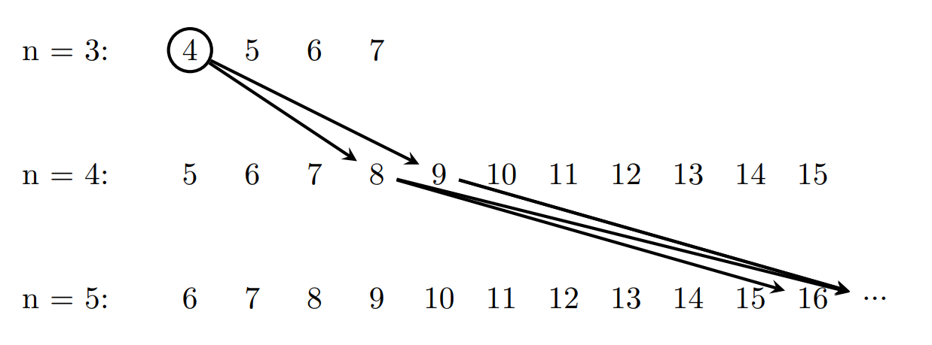

5. Study the average state complexity from 2.
This goal involves a detailed analysis of the average state complexity for languages represented by an n-state automaton with nondeterministic choices of initial states. Here we will heavily follow up results from bachelor’s thesis, and we will try to improve bound that was proposed in that thesis.
Understanding the average state complexity is crucial for predicting the efficiency of automata and establishing theoretical bounds. The derived theorem, presented in the thesis, outlines the upper limit for average state complexity.

Literature:
Markus Holzer, Kai Salomaa, Sheng Yu: On the State Complexity of k-Entry Deterministic Finite Automata. J. Autom. Lang. Comb. 6(4): 453-466 (2001)
Konstantinidis, S., Machiavelo, A., Nelma, M., Reis, R.: On the Average Complexity of Partial Derivative Transducers. Theoretical Computer Science 956 (2023)

